Intro:

## Prerequisites:

Typescript, Angular, Angular CLI.

## Key Concept:

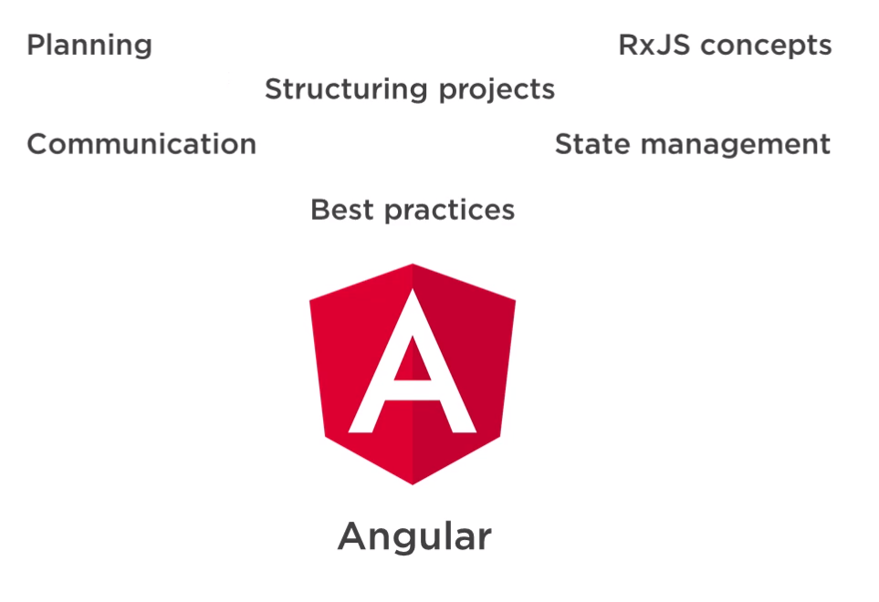

Different technique to build angular application.

* Structuring Modules
* Organizing Components
* Custom Lib
* Component Communication Techniques
* RxJS
* Managing State
* Custom Decorators, Pipes & More.

## Sample Application & Software requirement:

**GitHub:**

<https://github.com/DanWahlin/Angular-JumpStart>

<https://github.com/DanWahlin/angular-architecture>

**Software:** Node.js, Angular CLI, VS Code.

## Course Overview:

* Planning App Architecture
* Organizing features & Modules
* Structuring Components
* Component Communication
* State Management
* Additional Considerations

Planning App Architecture:

## Architecture Considerations:

* App Overview- What, goals, client use, business, benefits,
* App features- Some app features.
* Security- User Authentication & authorization, WEB API authentication
* Domain Rules- Validation,
* Debugging Strategy- App error logging
* Server Communication- HTTP, HTTPS, Web Sockets [**Data bandwidth**]
* Data Models- How to extract data for component in Angular.
* Feature Components- Structure Components, Components Communication.
* Shared Functionality- Third party components, KENDO UI, Angular Material etc.

## Architecture Planning Template:



Ask the team about these topics.

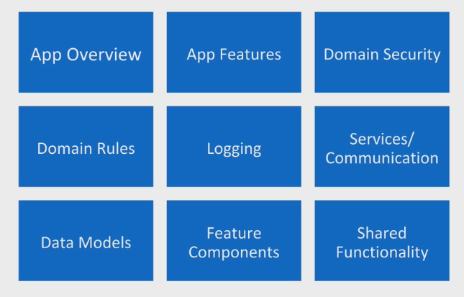 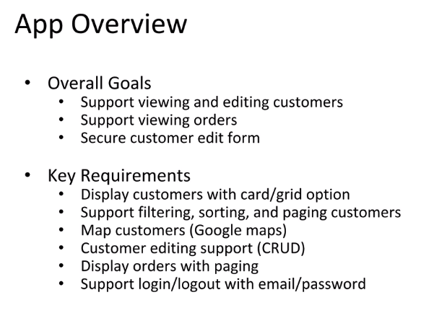

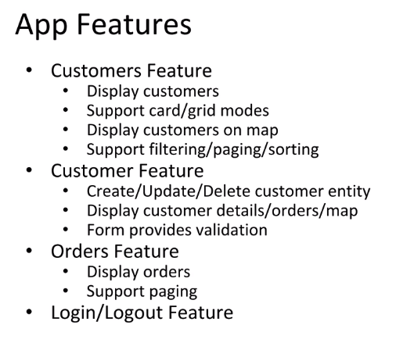 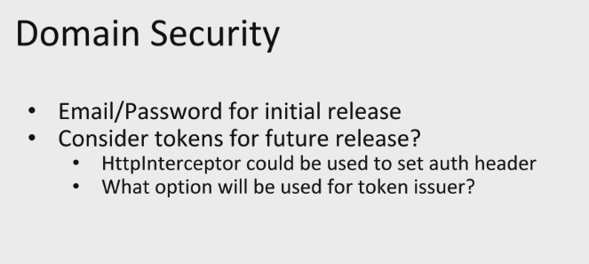

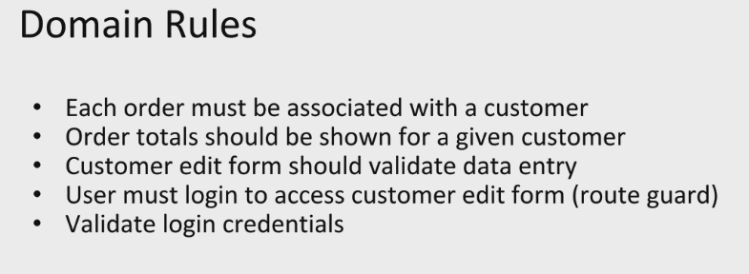 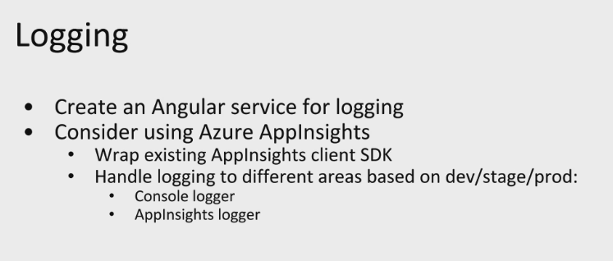

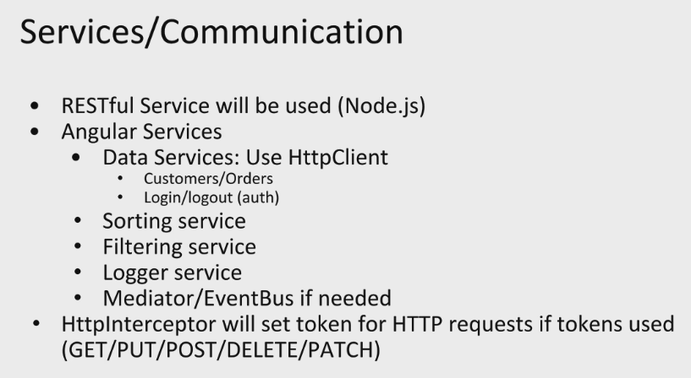 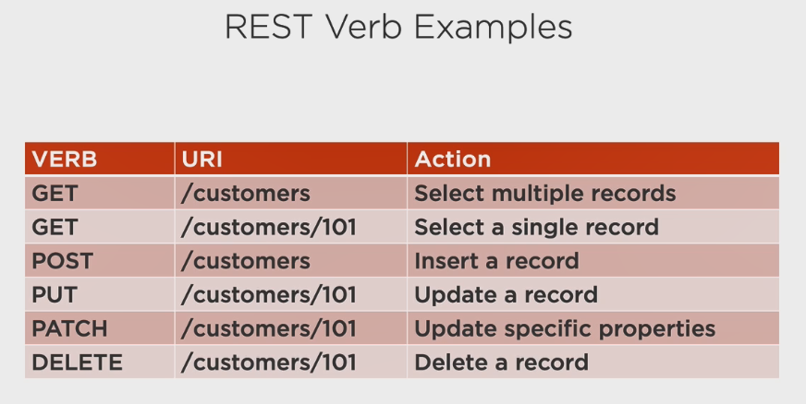

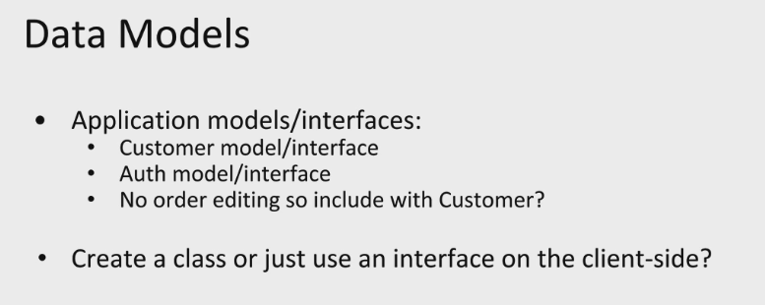 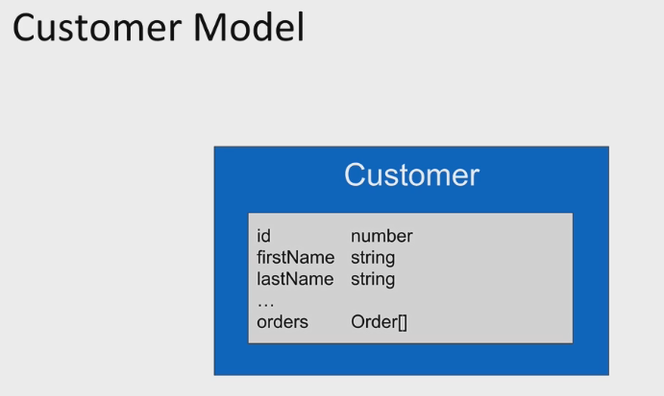

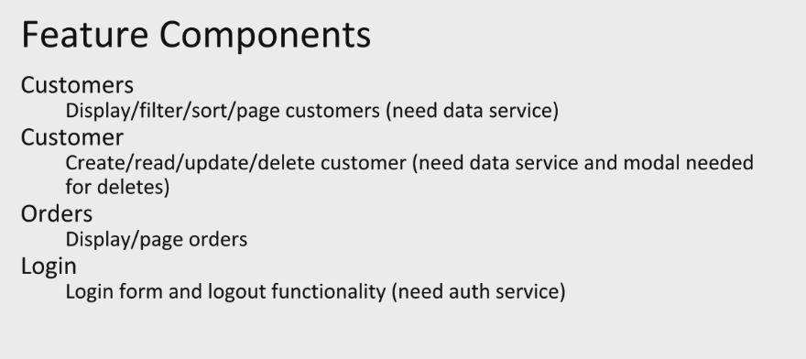 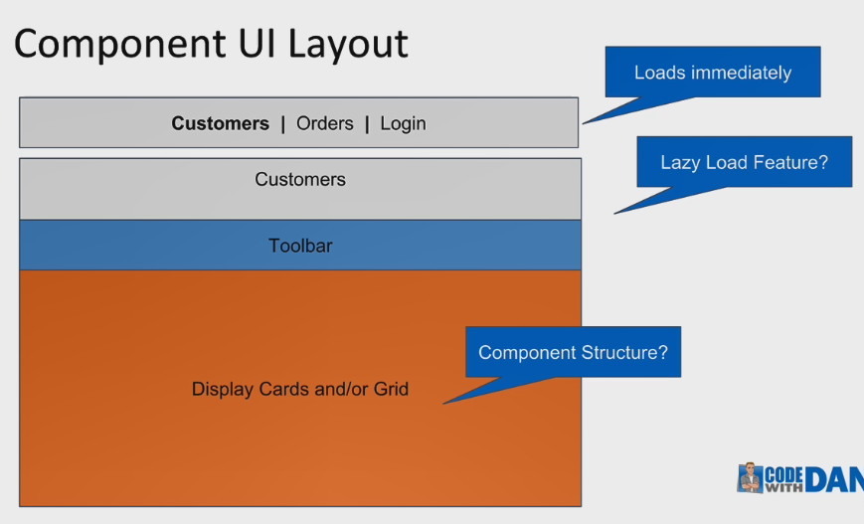

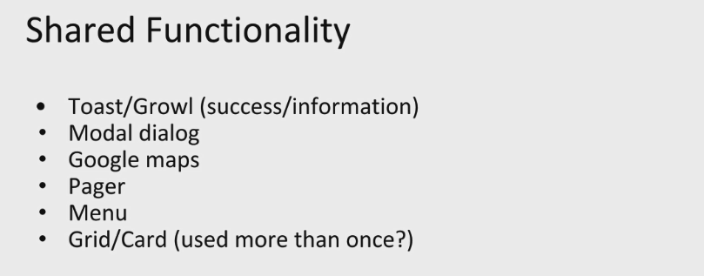 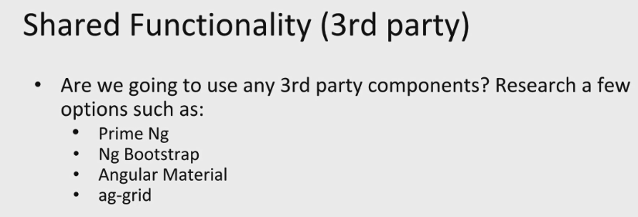

## Angular Style Guide:

<http://angular.io/guide/styleguide>

1. Coding Conventions
2. Naming Rules
3. Application Structure
4. Organizing Modules
5. Creating & using components
6. Creating & using Services
7. Lifecycle Hooks

## Other Considerations:

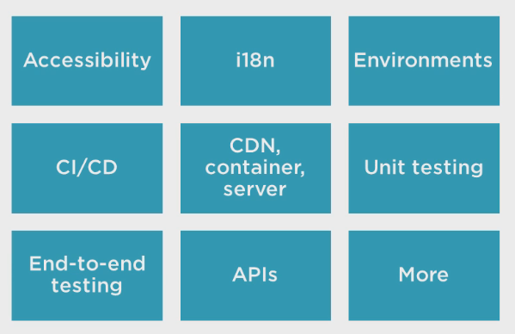

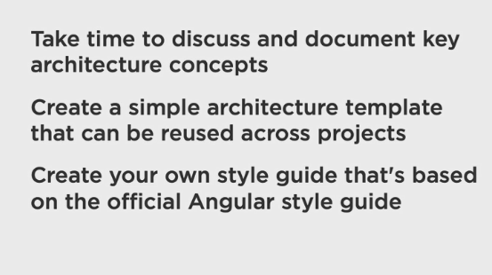

# Organizing Features & Modules:

## Organizing Features:

L - Locate Code Quickly

I - Identify code at a glance

F - Keep flat structure

T - Try to be DRY

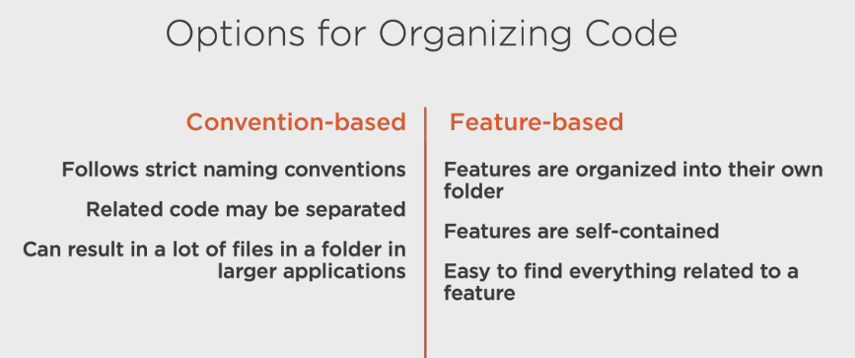

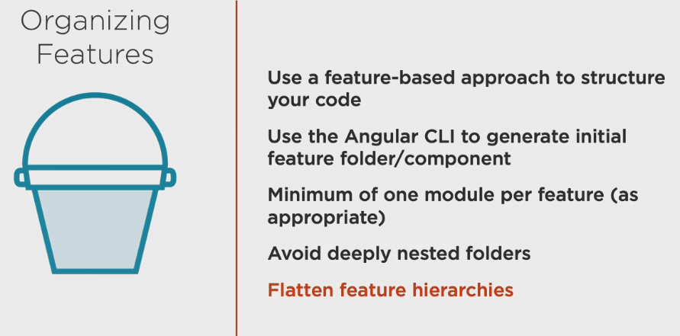

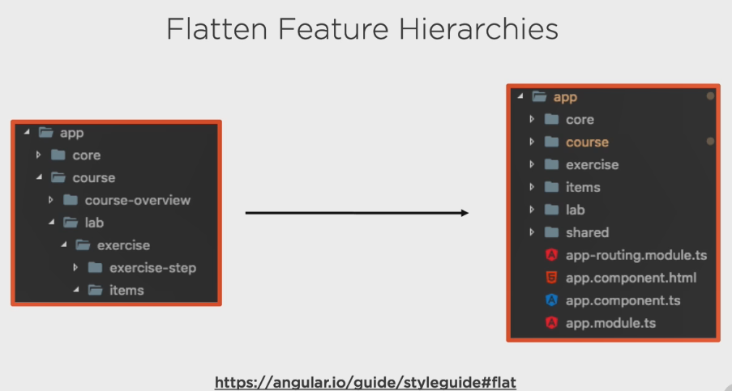

## Feature Module:

<http://angular.io/guide/styleguide#feature-module>

For simple feature - One Module per feature.

If its complex feature - Two module per feature.

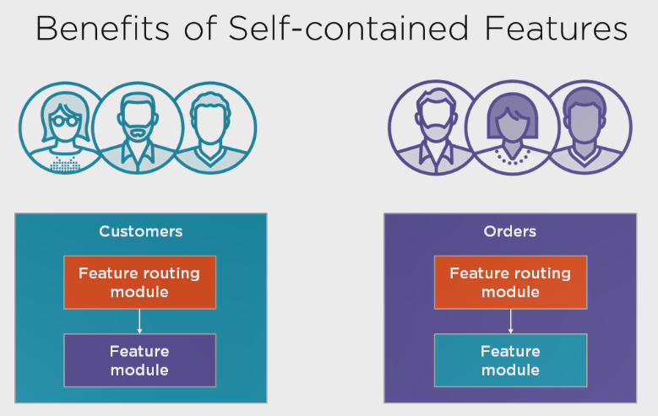

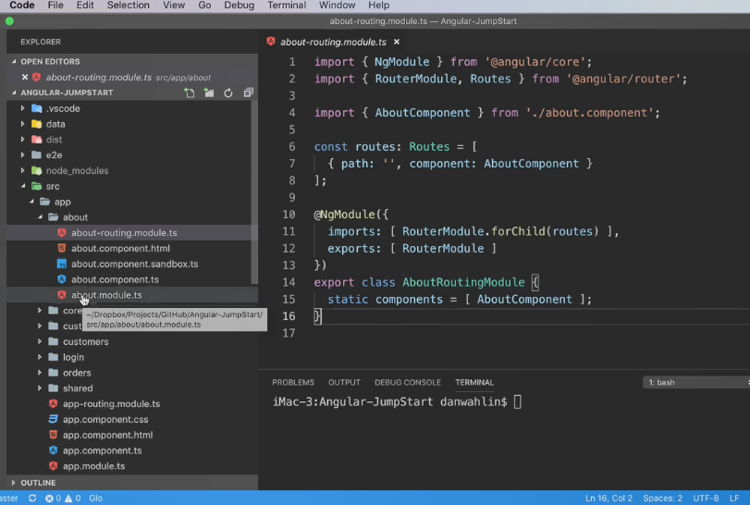

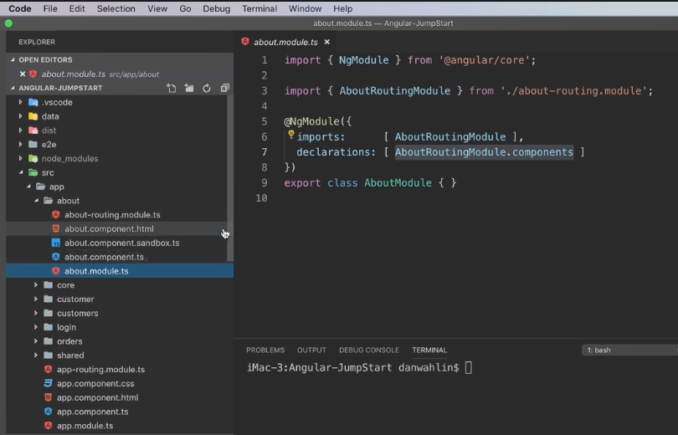

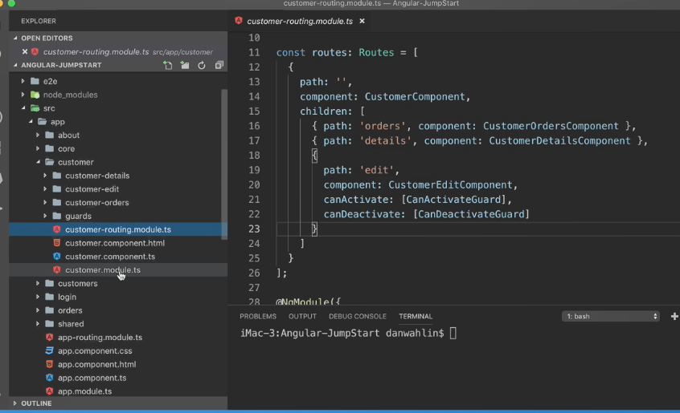

## Core & Shared Modules:

<http://angular.io/guide/styleguide#core-feature-module>

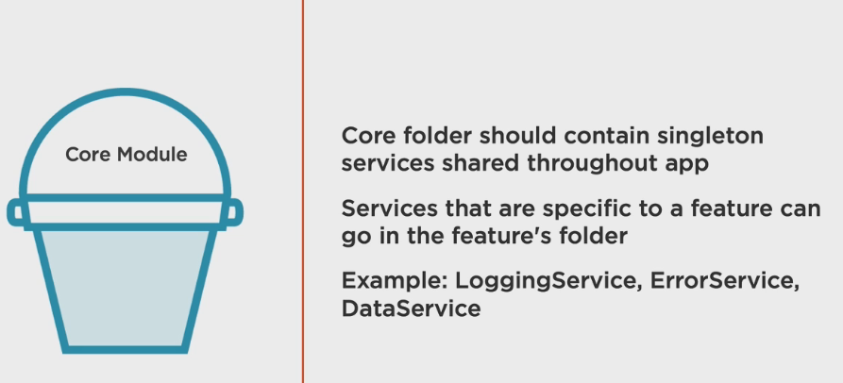

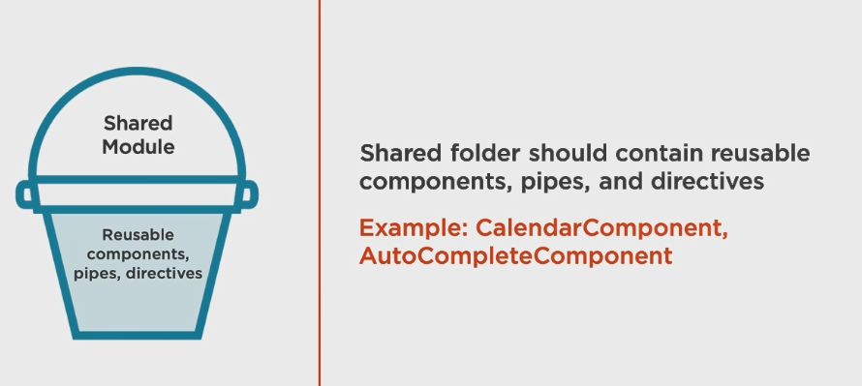

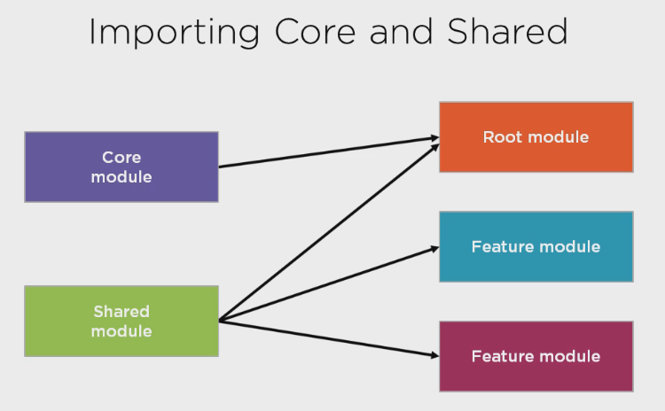

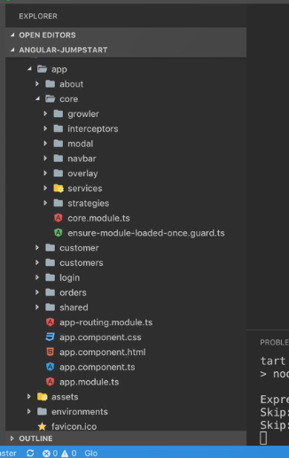 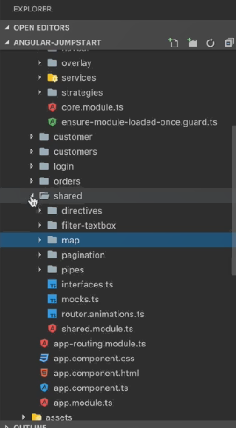

## Custom Library:

Share Component across many applications.

Angular 6 above support custom lib.

